**NEAR EAST UNIVERSITY**

Faculty of Engineering

Department of Electrical and Electronic Engineering

**Summer training (1)**

EE200 – STAJ 1

Student:OSAMA ELGAZAR

ID No. :20185707

Supervisor: Dr.Samuel Nii Tackie

Nicosia – 2020



**TRAINING:**

These are all explained in the previews pane.

First: The designer teaches us how to research project design and technological electrical design, and shows us the connections to a building's or home's electrical lines from within.

The second tells us the network of the electrical pipes in the tile

Display turn. We split the walls to fasten the electric pipes

Third: We learned how to repair electrical tubes in walls and teach us how to lay electrical cables and wires inside any of the electrical tubes for the home.

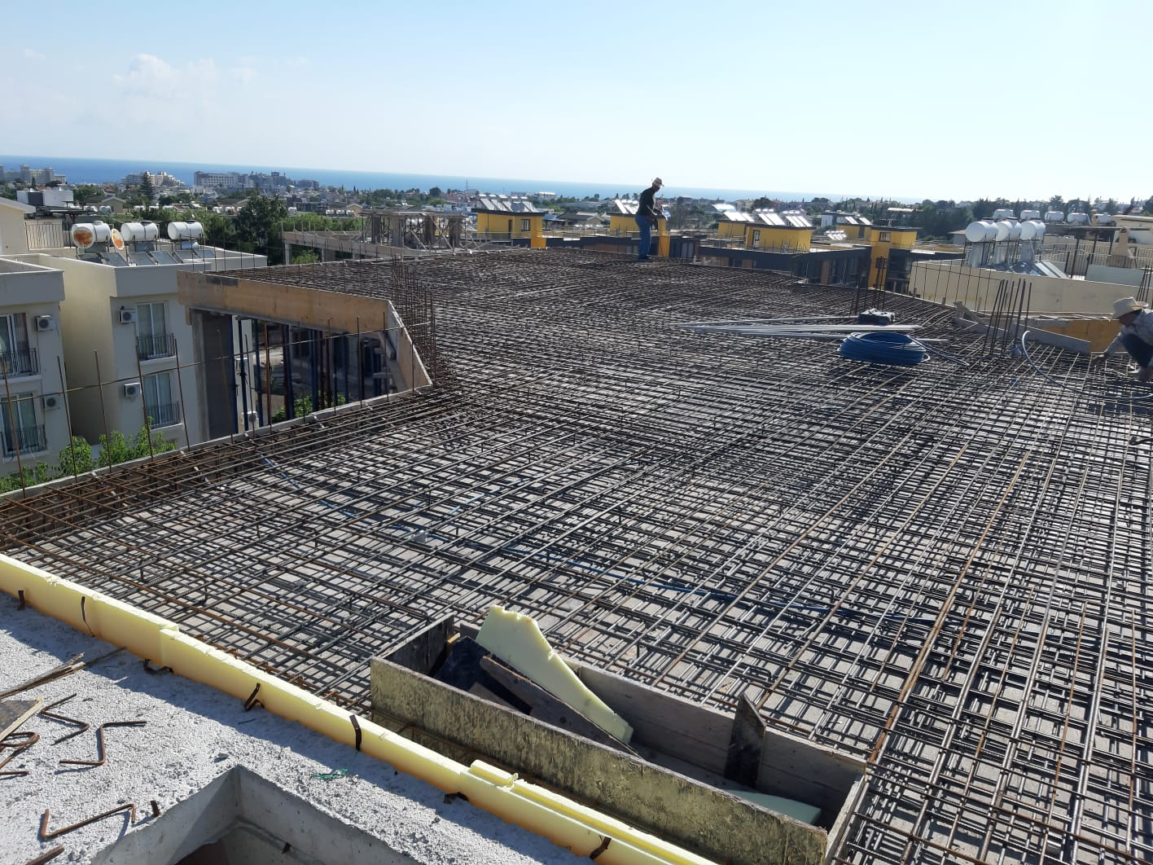

**First, I need to explain what electricity is**:

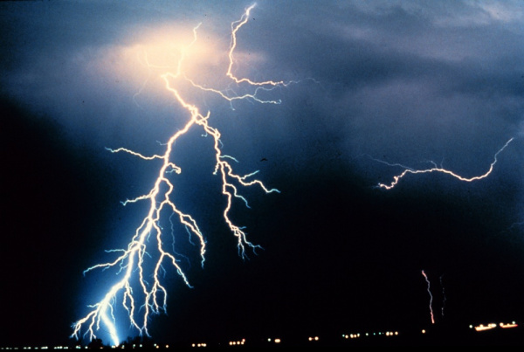

All around us, electricity is powering technology like our cell phones, computers, lights, soldering iron and air conditioners. It our current society, it is difficult to leave. Even if you are trying to escape electricity, it is still at work throughout nature, from the lightning in a thunderstorm to the synapses within our body. But what is Electricity exactly? This is a rather difficult issue, because when you search further and pose more questions, there is still no conclusive solution, just theoretical representations of how electricity communicates with our climate.

Electricity is a common process that happens in the entirety of nature and has various types. In this tutorial we will focus on current electricity: the stuff that fuel our electronic gadgets. Our aim is to understand how electricity moves through wires from a power source, to light up LEDs, to spin motors and to control our communications tools.



Electricity is briefly defined as the electrical charge flow, but that simple statement is so much behind. Where do the accusations come from? How are we going to move these? Where are they moving in? How does an electric charge cause mechanical movement, or light things up? So lots of questions! To start explaining what electricity is, we need to zoom into the atoms that make up everything we interact with in life, beyond the matter and molecules.

In particular, this tutorial builds on some basic understanding of physics, strength, energy, atoms and [fields](http:/en.wikipedia.org / wiki / Field (physics)). We will gloss over the basics of each of these concepts of physics, but it can also help to consult other sources.

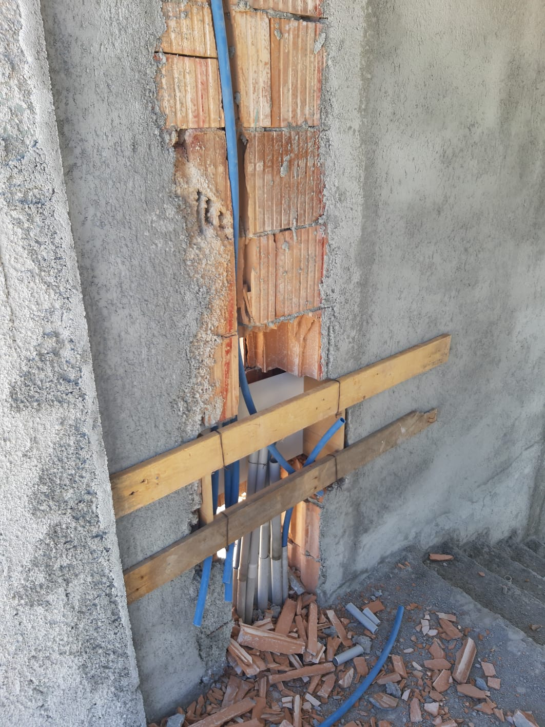

**Internal and external extensions:**

Domestic electrical systems, which are general electrical services for the whole building, comprising of many distinct and independent circuits, including lighting circuits, electrical outlet circuits, electrical and private equipment, building gardens, house walls and doors, which are usually external illumination, which is one of the house's public circuits which needs care that varies.

The electric current used in this and other electrical research in homes is the alternating current (AC) & (DC)

The branch connectivity used in this business is

The electrical voltage used in the home is mono (carbon-nitr), which is a basic voltage, which is the phase difference between carbon and nit-220-volts and 110-volt in certain nations.

**The things I learned from this training**

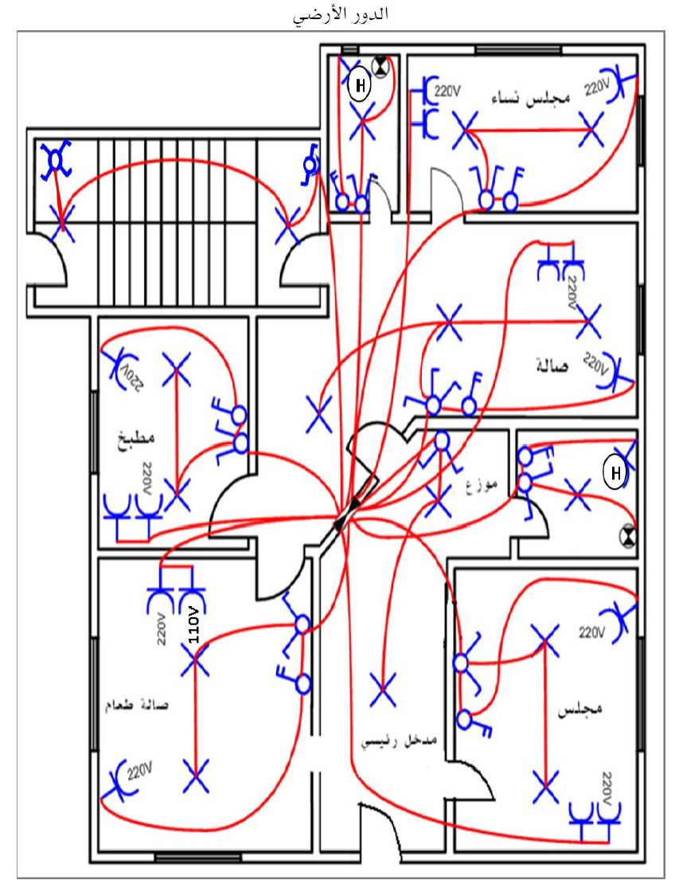

Before beginning the job, we planned the electrical network in advance and defined other issues, including the number of different lighting loops, the position of lighting points, the collection of suitable wires and parts for each circuit, the amount of electrical wires going through the predetermined plastic tube allocated to each circuit and the locations.

Carrying out electrical work (extensions) goes through many phases and these steps are parallel to each other and, at the outset of the process, we put in effect an administrative schedule for the process that we should undertake and draw on the map everything that is required for electrical installations in the building, such as the amount of circuits for the building and the electrical switch and socket and poi positions.

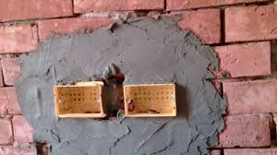

Which is the second kind known as the circuit network as it creates a loop from two beginning points and back again which is defined as the device (the ring) and this sort relies on the movement of electrical wires from the electrical plate to it such that the side junction boxes may be minimized and relies on the roofing light points boxes in the connections.

Thus, we summarize that the first type extends the electrical wire feeding from the plate to the special junction box for a circuit or room and in this case the electrical wire is distributed and connected, then the electrical wire is extended from the junction to the light point and from the junction to the electrical switch and from there to the junction box and the wire is connected.

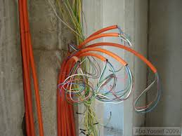

The second method will not vary significantly from the first, but the junction boxes will be the checkpoint points where the wire travels from the plate to the light point where returns to the main box and from the switch to the plate and the linking mechanism will be done on the ceiling inside the lighting box and the third style incorporates that with this and both are accurate and the methodology is right, Based on the condition on the field, so we may split the lighting circuit into two circuits (room or lounge) in one location. The ceiling will keep the wall lighting circuit in a connected state, so it will not cut off electricity from this room until the repair is complete. When we say a circuit of lighting, we mean a collection of lighting devices that link to this circuit.

**Separating and connecting electric lighting circuits:-**

The circuits are controlled by lighting many sophisticated and technical lamps, and we mention the common ones, each of which has a place that fits with the point of light that they will control.

1. A normal circuit breaker switch to connect and disconnect the current at the same place from one bright spot.

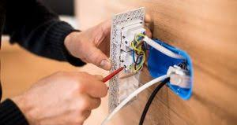

2- A double-circuit circuit, which means two electric switches, each key controls a separate light point from the other. An indication of this is that we are using this circuit for an electric rich one with ten bulbs.

3- Direction circuit (reciprocal) This circuit controls a light point or more than two different locations where the light point can be operated from one location and separated from another location and vice versa. This circuit is used at the beginning and at the end of the hallway in bedrooms and rooms with two entrances also in the hallway and is often used at the beginning and end of the stairs (ascending).

4- The cross-switch circuit (called a triple direction) and this circuit is used to control the lighting from several places that exceed three and above. This type of switch is used with the Drixion keys and it is the assistant for this and it is always between the two drones and whenever we want to increase the number of places we want to operate from them we only have to put Treble switch to endless and this type is used in the long corridors and in the staircase construction (large building)

Whatever the type or shape of the switch is different, the connection process does not differ and the basic principle does not change.

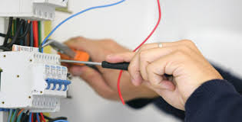

The process of connecting the electrical wires in the switches is clear and well-known, and under the screw at the place designated for that. Once performing, the electrical wire start must be properly stripped while the stripped portion is put under the screw and firmly secured. Striped from the wire and gets well unplugged.

Brief Distribution

The single switch has two positions to position electrical cables, a location to put the feeder cable, which is also symbolized by it (L1). The other location is for the feeding line to the light stage.

The double key does not differ from the first but here we make a small connection between the two keys and connect them to the feeder line and each key becomes a light point and comes out two lines separately to feed the light.

Drakes ion has three places to position the wires first assigned for feeding and the two remaining places are for the cycle of interchange between the Dirksen and the other to link them to the other Dirkisun lighting side.

The Triplet Draxion (chiasp is between two Directions)

There are other electrical loops, but these are the most growing and essential for home usage.

There is a form of switch called a dimer which is based on the variable resistor theory which raises and lowers the tone, but this raises and reduces the luminance strength.

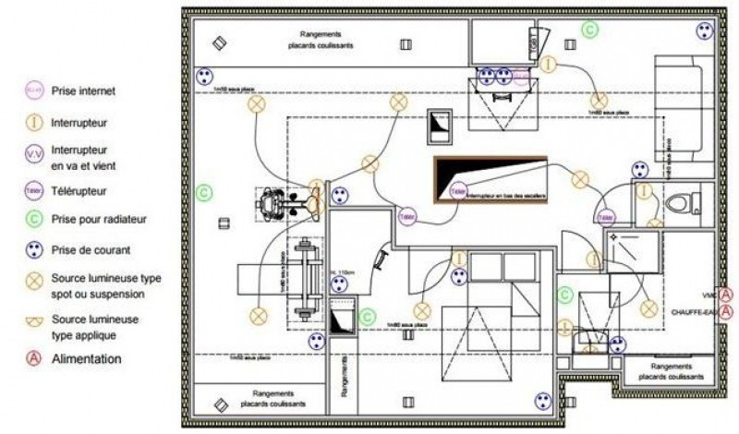

There is a so-called current shock circuit breaker (teleporter) and it uses a compressor switch so it operates at low stress and is used in bathrooms and functions on the magnetic induction theory

There is also a form of electrical switches that regulate the lighting and use the regulate ash (to detach and link the lighting or to decrease and increase the lighting brightness

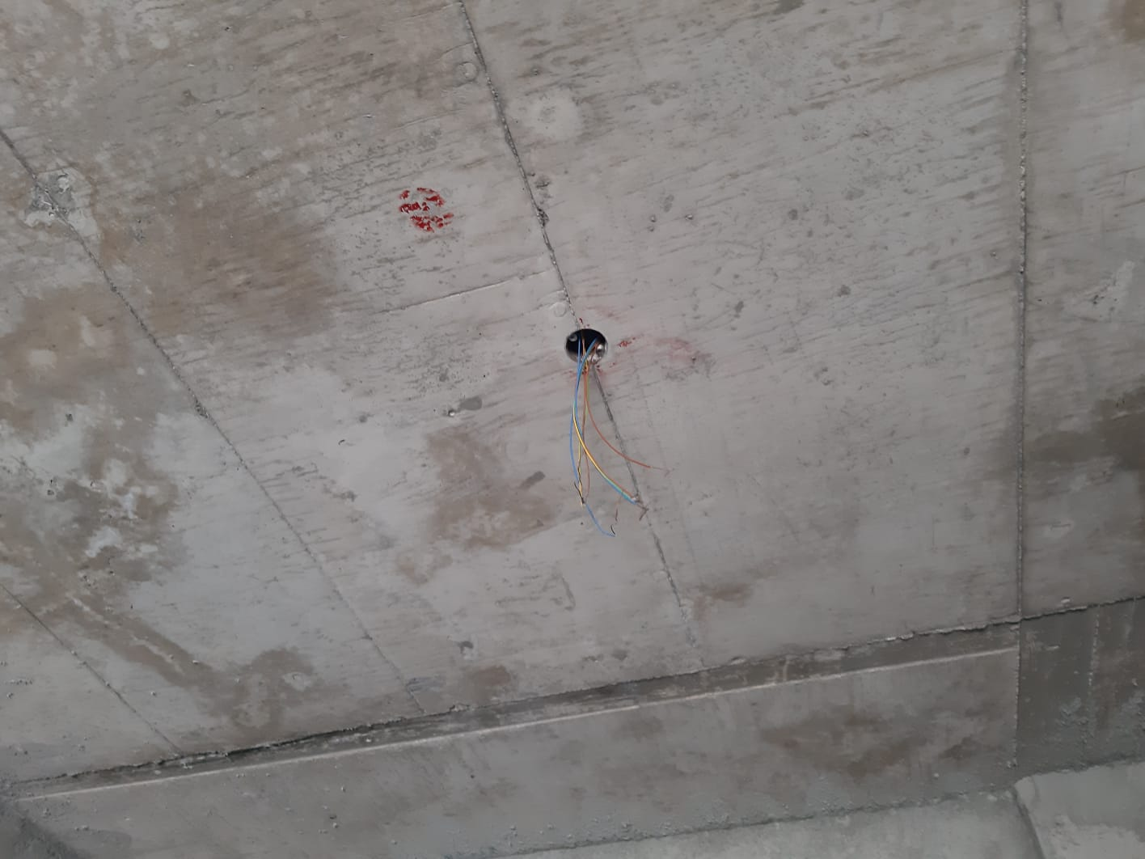

It determines the number of electrical wires and their points for each circuit and the caliber of the circuit breakers and the calculation of the house's full electrical capacity, and consequently the start of work and work has a beginning and an end, and the scheme shows us how the start will be in order to reach the work stages at the end, which is basically the stage that we will take, The scheme is the greatest reference for us because it tells us the beginning and the end of the job and the first phase in the job is on the roof of the house and before pouring the surface (laying concrete) we expand a network of plastic tubes into which the electrical wires move in the later stages and decide the positions of the ceiling lights in this plastic network.

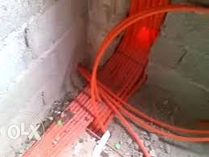

The second stage, which is the basis and very significant, is the plastic extension stage

(1- Rubber tubes-cable-2- Contact boxes-3- Change boxes-4- Board disconnectors-Tablo

The plastic tubes must be extended horizontally or vertically, knowing that we can wrap the tube because it is flexible and responds to us in that, but it is preferable that the curves are few and that this network must be connected through the link boxes (link) and then the key boxes from the distribution plate.

The sizes of the plastic tube (tube) must be chosen with a diameter that is proportional to the number of wires passing through this or that tube, and this is known from the scheme where the number of wires is indicated for each circuit or the number of lighting points and there are several tube sizes, and we mention them-13 mm-16 mm-18 mm-21 mm and there are large sizes.

Electrical junction boxes are plastic square boxes, and they have different sizes and are a common measure for junction boxes according to the need for that.

10 B 10-12 B 10-15 B 17-There are larger sizes than this, and the round shaped cans are used.

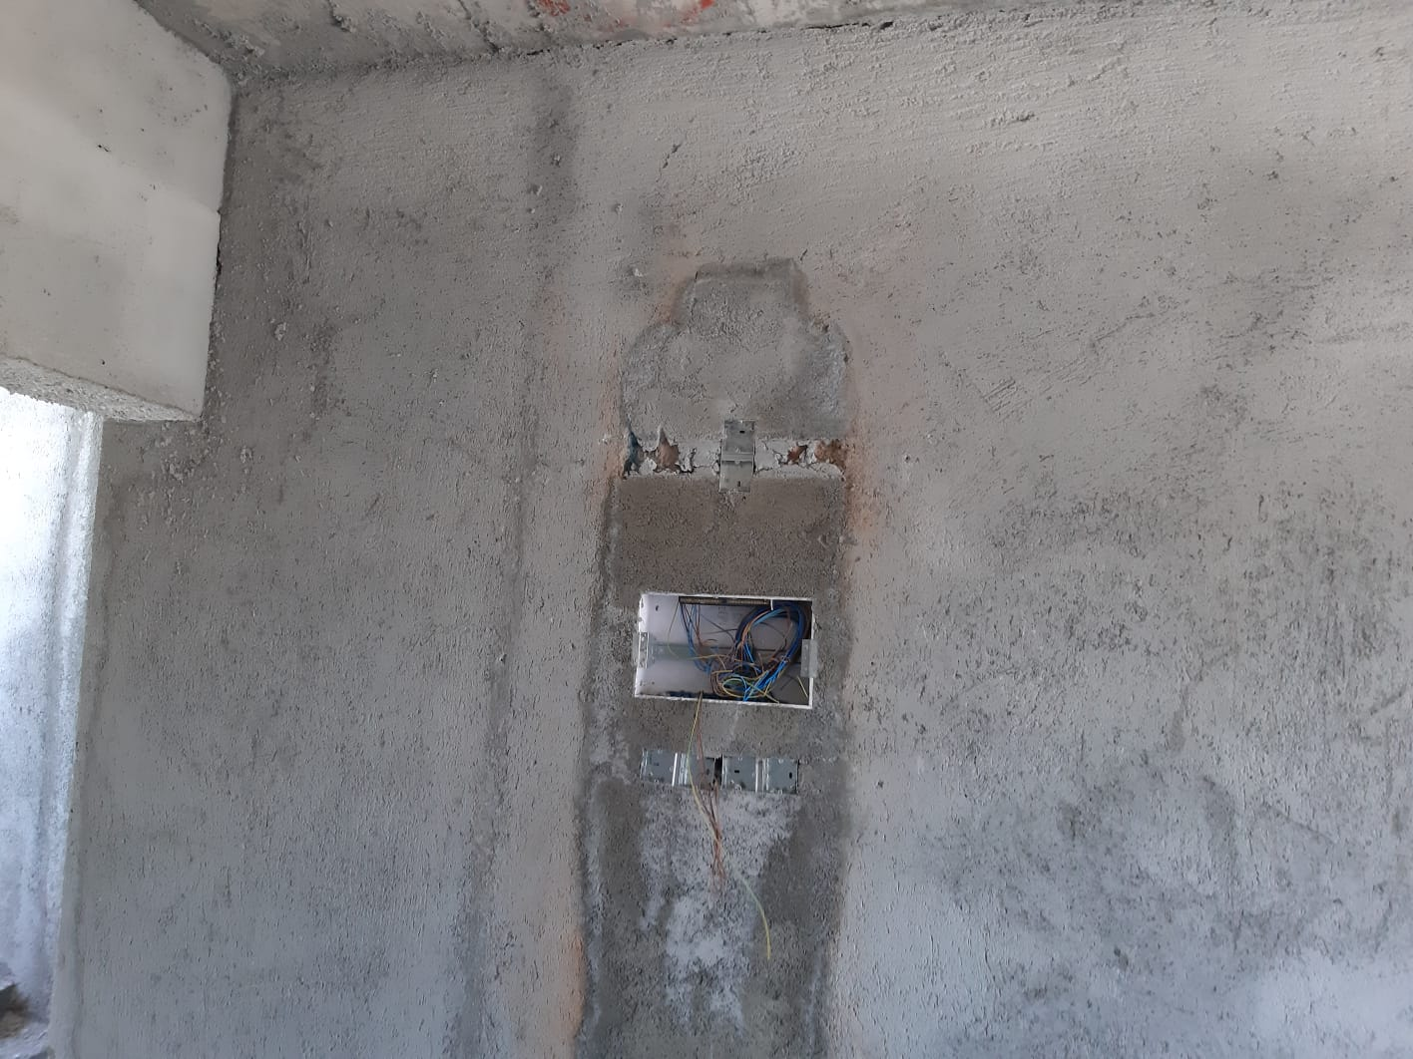

Such cans are mounted on the walls and attached to the tubes which, on the one side, minimize the width of the tubes, so that the electrical wires can be linked to it and provide a plastic cover to check for faults later on, which can be placed at a width of 30 to 40 cm from the house or space, depending on the height of the building.

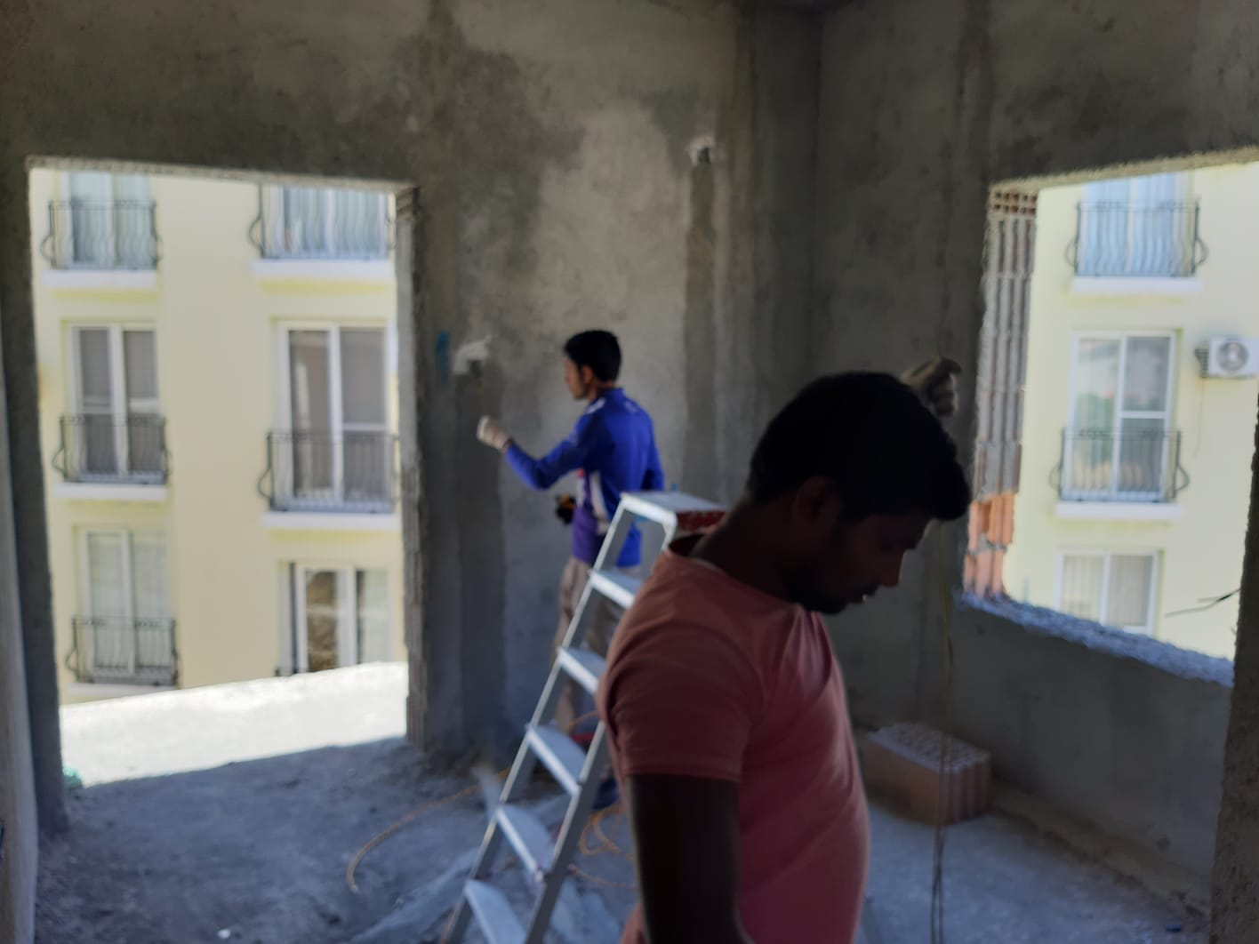

Key boxes are rectangular plastic boxes that are intended for the installation of keys and electrical sockets and installed in the house according to what is shown on the scheme in order to avoid randomness and abundance of useless ones and install boxes designated for keys to lighting rooms at the entrance to the room next to the door and away from the edge of the door about (15-25) cm and a height from the surface of the tiles About 130 cm This is for connection boxes and switches for electrical circuits.



With regard to the weak current, which is the telephone lines and the antenna (TV), this will have a network of plastic extensions and their own connection boxes, which means that they are separated from the electrical wiring and the key boxes that are dedicated to placing the telephone and the antenna socket, installed at about 60 cm to 70 cm height of the tiles' surface.

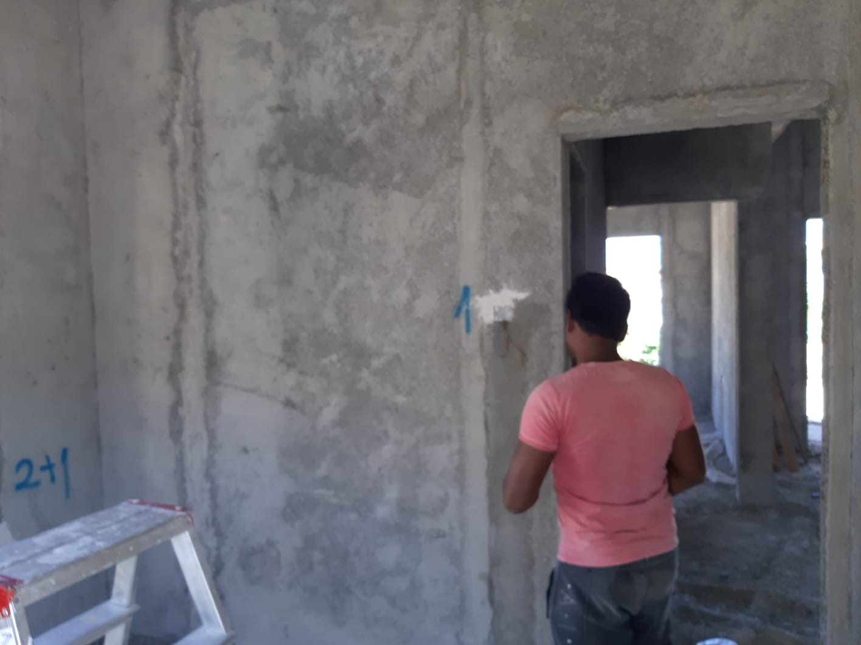

Light loops include primary and indirect light, include ceiling lighting and wall lighting, including unique lighting and lighting systems, these are usually lighting points, Including neon (fluorescent), including different forms of electrical lamps (metallic-energy efficient-spots-holgin), including suspended and side illumination center and back Wall (column) including electronic candlesticks (candlestick).

Taking into account many issues, including the esthetic factors in a manner that is proportional to the furniture in the room, and most significantly, taking into account the light flux and visibility that offers psychological relaxation and, hence, mathematical operations for this light flux, appropriate for any position in the house.

There are two styles of extensions for illumination and the third type is a combination of these two styles.

The first form is what is recognized as what is referred to as a network of junction boxes mounted at the first point of the construction. This type is to distribute electrical wires from the electrical board to these boxes for the lighting circuits, which are linked and attached to the wires and from there you go back to control the electrical switches and the ceiling light points and these cans are the link between the electrical plate and the switches and the ceiling or side light points, So the wires in this box are well and securely attached and are then returned to them for servicing or reconstruction and provide an exterior cover to protect the wires upon completion of the contact phase To order to eliminate these boxes in the seating places and spaces, we seek to position them in the corridors of the house and in the correct positions and the electrical cable does not stretch for long periods.

[](https://cdn.sparkfun.com/assets/a/0/9/4/0/51a52b62ce395f2f25000001.gif)

Schematic: A battery (left) connecting to a lightbulb (right), the circuit is completed when the switch (top) closes. With the circuit closed, electrons can flow, pushed from the negative terminal of the battery through the lightbulb, to the positive terminal.

While the electrons move at a snails pace, the electric field affects the entire circuit almost instantly (we're talking speed of light fast). Electrons throughout the circuit, whether at the lowest potential, highest potential, or right next to the light bulb, are influenced by the electric field. When the switch closes and the electrons are subjected to the electric field, all electrons in the circuit start flowing at seemingly the same time. Those charges nearest the light bulb will take one step through the circuit and start transforming energy from electrical to light (or heat).

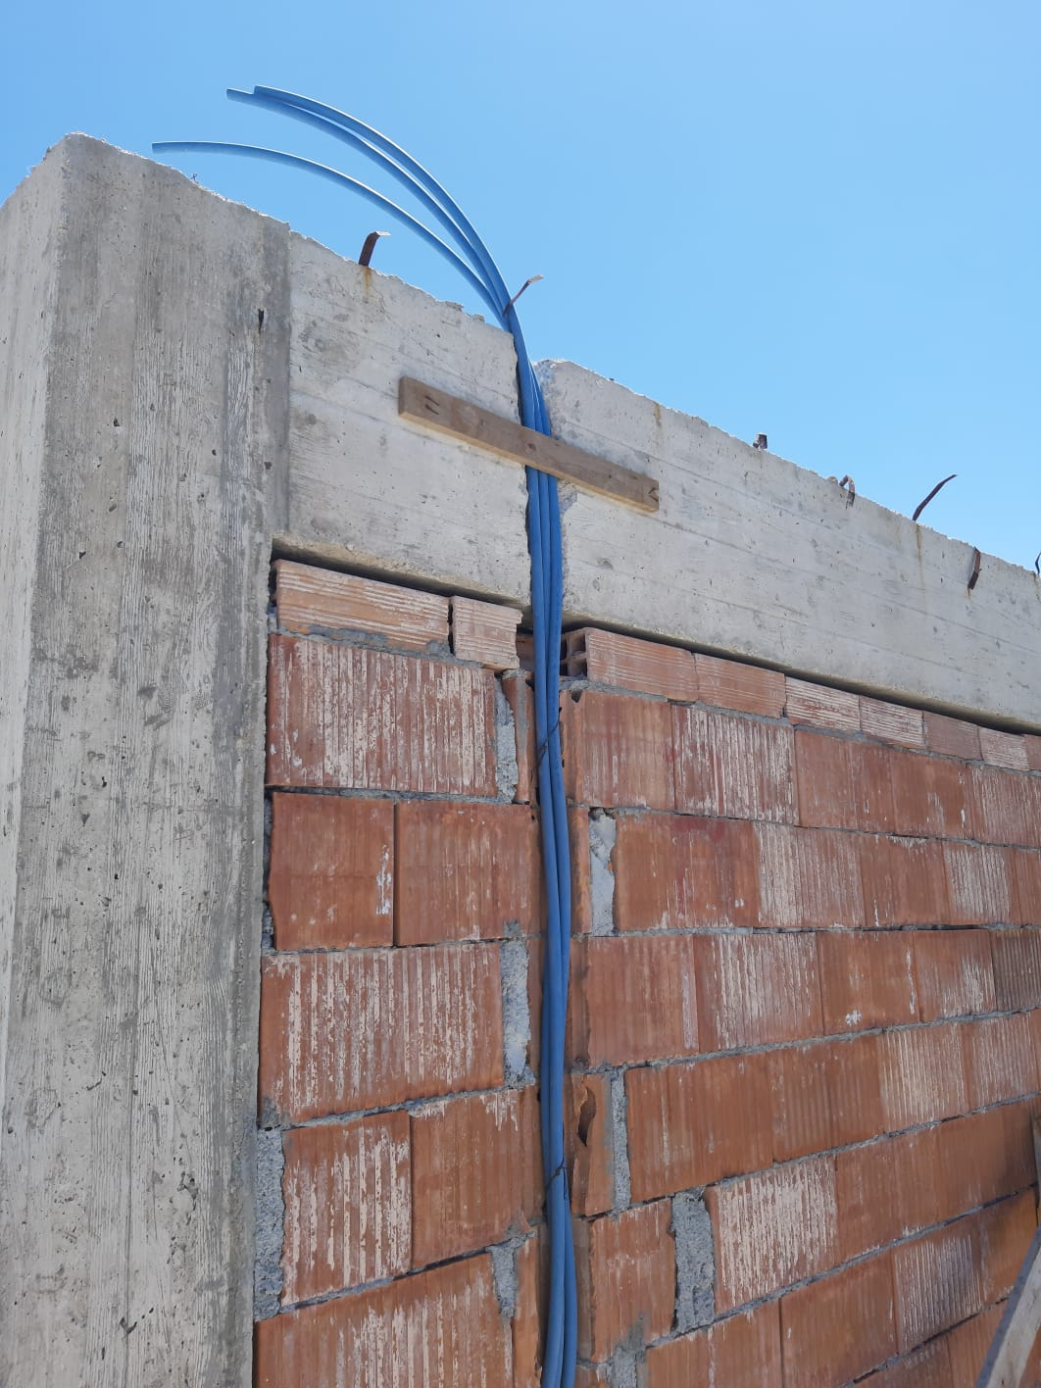

**Name: OSAMA ELGAZAR**

**ID: 20185707**

**Finally, Thank You**